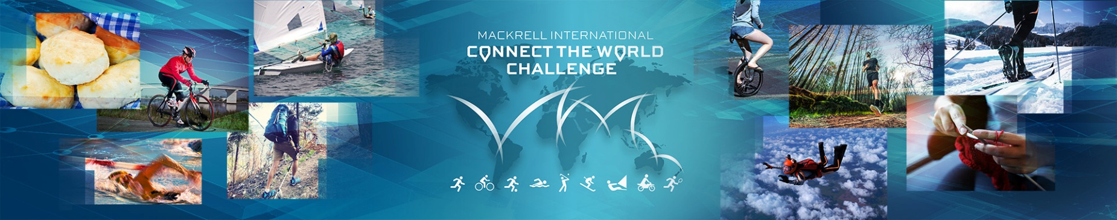
Sponsorship Form
Raising funds for UNICEF and Larchfield Children's Home
Name:
Mackrell International Member Firm:
My Connect the World Challenge is:

My fundraising target is:

Name | Address | Donation per km/item/event | Total Donation | Received
Please donate funds raised by visiting www.connectchallenge.net
www.mackrell.net www.connectchallenge.net

